Plotter for Callisto FIT-files

The Python tool 'Plott_FIT.py' allows to plot, zoom in- and out as well as saving the dynamic spectrum as a png-file from Callisto spectral overview.

**Requirements are:**1. Python 2.7 (from Anaconda) and Spyder for Python 2.7  
2. Callisto FIT-file(s) to plot

No editing of the script required unless you want to change color table and or you want to change label-sizes and/or tick-sizes and/or graphic format, e.g. jpg instead of png. Or change of z-unit (digit, mV or dB).

**Usage:**a) Either open Spyder and load the script Plott_FIT.py. Open a python console (no iPython!) and run the script by pressing function button *F5* or press green triangle at the top of Spyder.  
b) Or open a DOS-window, go the folder of the script and type *python Plott_FIT.py*.  
c) Or double click the batch file p.bat which you may put as a link to your desktop.  
Once the script is running you get a window to select a file as shown in figure 1.

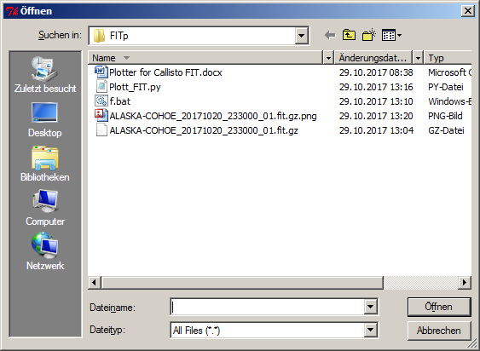

Fig 1: File-dialog to select Callisto spectrum

Select a file you want to plot and within a seconds or even less you get the full size plot of the spectral overview with x-axis expressed in decimal time (UT) and y-axis expressed in MHz. In case you want the plot in dB instead of mV, just change the equation in the script.

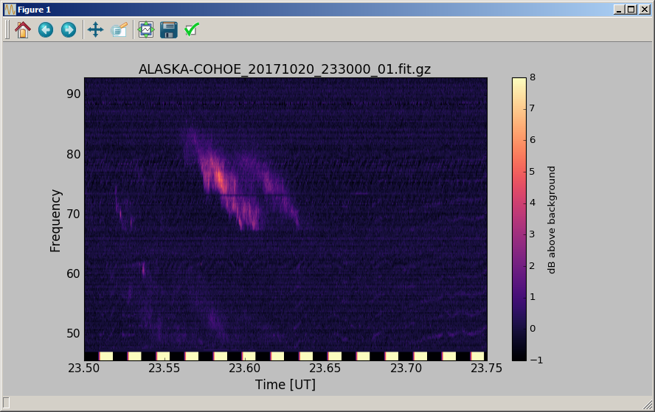

Fig. 2: Dynamic spectrum in full size.

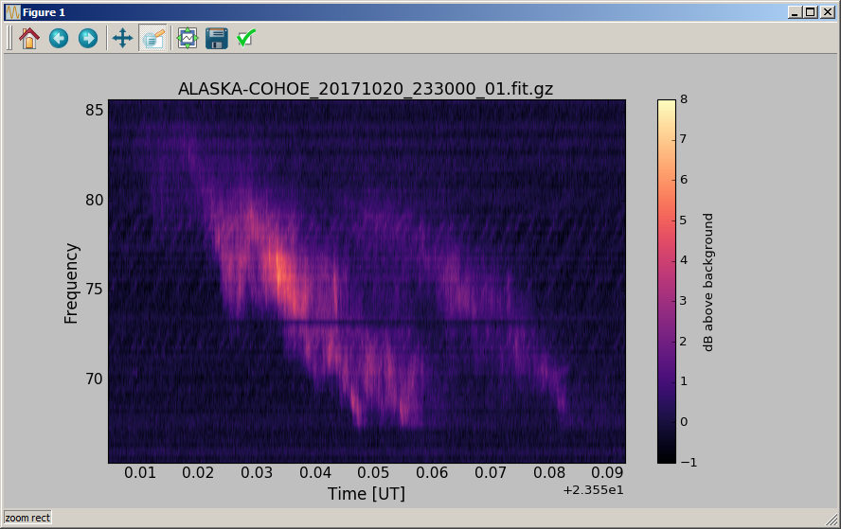

Fig. 3: The same as figure 2 but now zoom into 1st harmonic.

At the top of this plot there are 8 icons visible. The icon number 5 allows you to zoom in x and y, while the icon number 4 allows to move the plot inside the window. Icon 6 allows to configure subplots and icon number 7 allows you to save the plot in 9 different graphic formats. Icons 1, 2 and 3 allow to change views.

File: Plotter for Callisto FIT.doc, version 0.1, 29.10.2017, Chr. Monstein